**Software Design Document - Appendix A – Class Diagram**

1. **Full View of Class Diagram**

You can check FullClassDiagram.png file for detailed view of the class diagram.

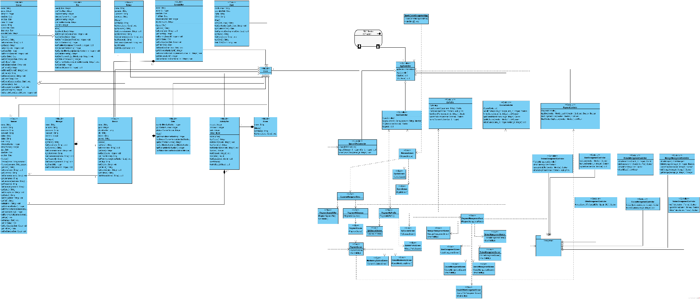

1. **Detailed View of Left Part**

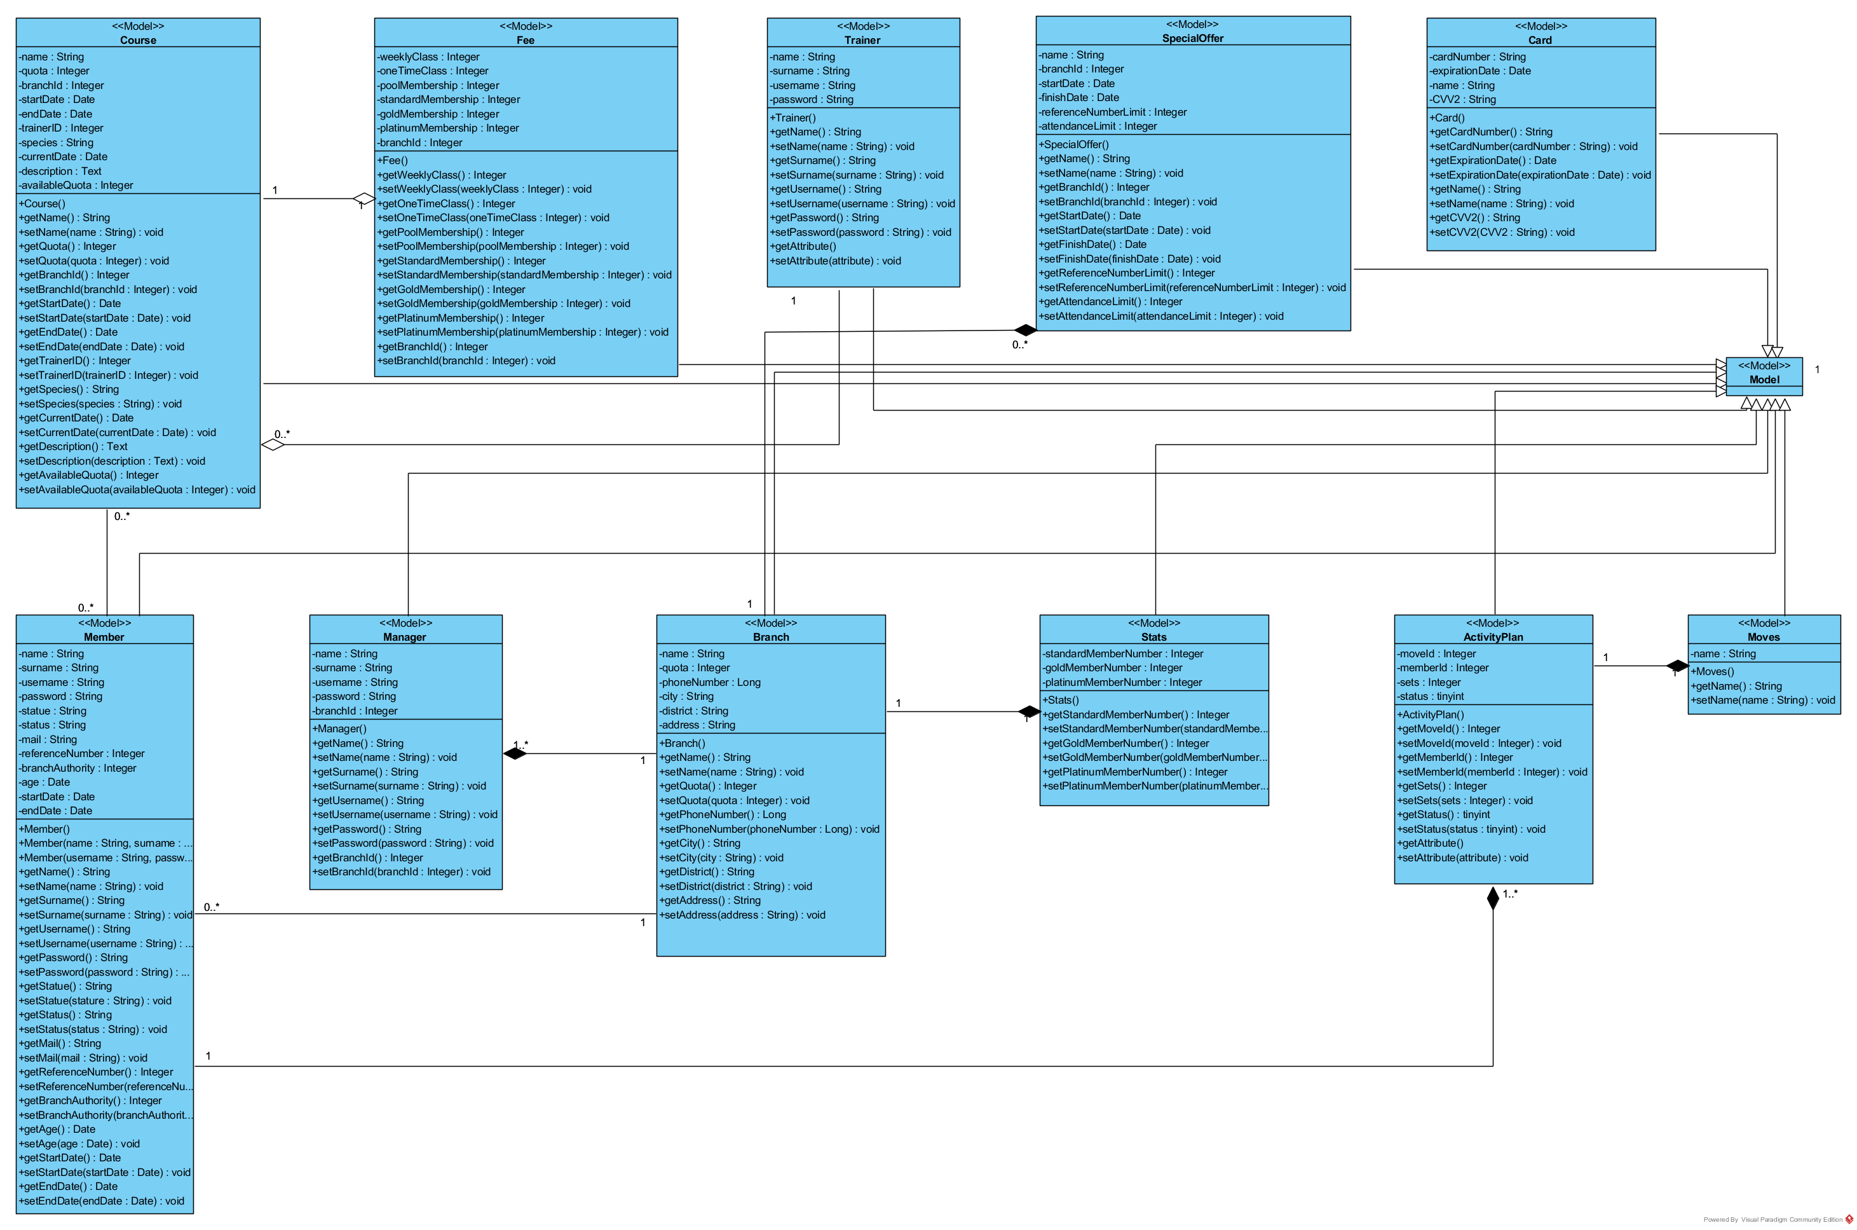

1. **Detailed View of Right Part**

